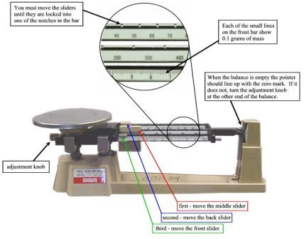

**How to read a triple beam balance**

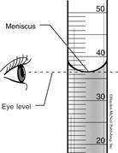

**How to read a graduated cylinder**

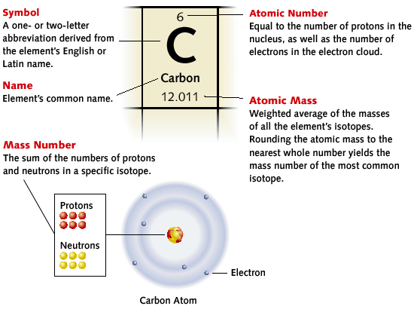

**How to read a periodic table square**

**How to read the periodic table**

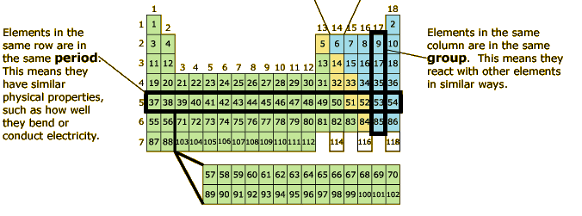

The Group Number (across the top) tells you how many valence electrons each element has. So, every element in Group 1 has 1 valence electron and are therefore VERY reactive.

The Period Number (down the left hand side) tells you how many energy levels an atom of an element has. So, all elements in period 3 will have 3 energy levels.

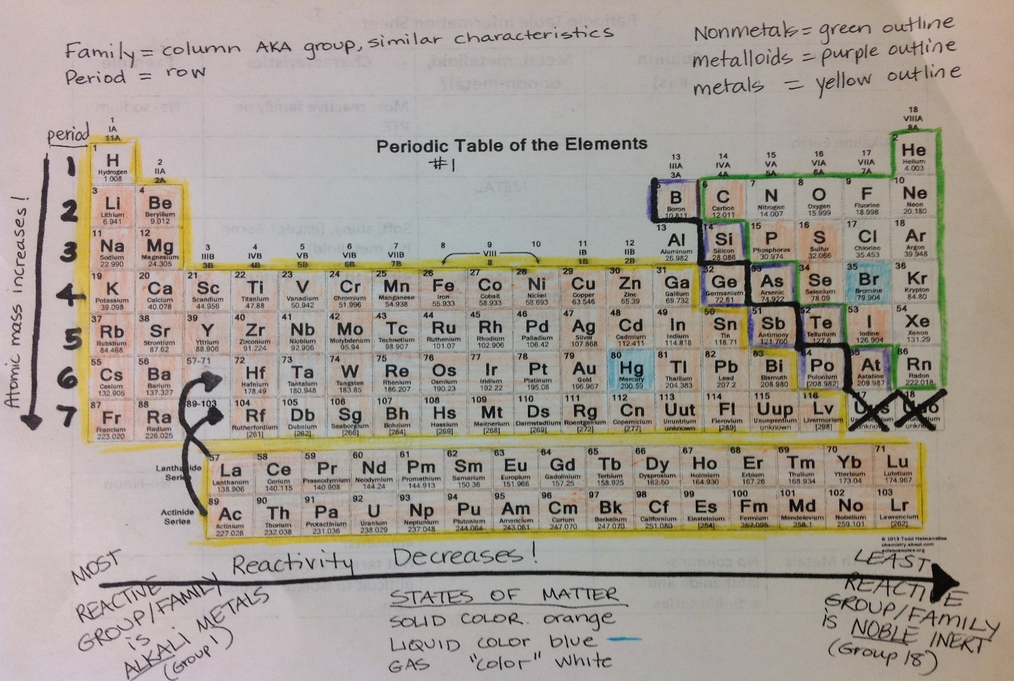

**We will learn about all of the periodic table trends in our next unit so for now, just recognize how to read the squares, that elements in Group 1 will be most reactive because of # of valence electrons and elements in Group 18 (or sometimes 8) will be non-reactive because they have 8 valence electrons.**

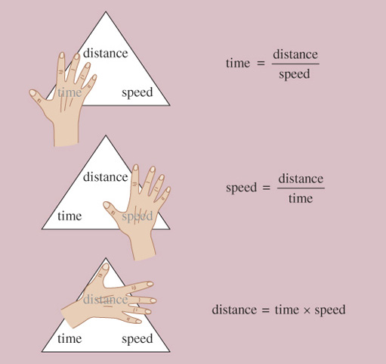

**Cover up the variable you are trying to find and then perform the operation that is left.**

**Ex. If I’m trying to solve for speed, I would divide distance by time.**

**How to use the formula triangles for calculations**

**[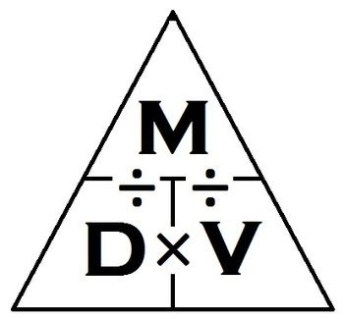](http://www.teacherspayteachers.com/Product/Science-Journal-Density-Triangle-Clipart-436071)**[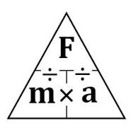](http://www.google.com/url?sa=i&rct=j&q=&esrc=s&frm=1&source=images&cd=&cad=rja&uact=8&docid=HE23xL9xUS9E1M&tbnid=UT8u2LGZ8JQ_6M:&ved=0CAUQjRw&url=http://www.pinterest.com/pin/23362491792425394/&ei=pYcDVJb9D5ecygSHuoHQBQ&psig=AFQjCNEG8KSPenIFeyqgbb8KLMyr7FvqAA&ust=1409603839048123)

**Density = Mass/Volume**

**Force = Mass X Acceleration**

**[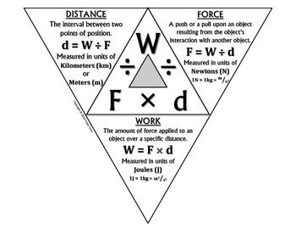](http://www.teacherspayteachers.com/Product/Science-Journal-Work-Triangle-Foldable-Completed-1166063)**

**Work = Force X Distance**

**How to draw a Bohr Model for an atom of an element**

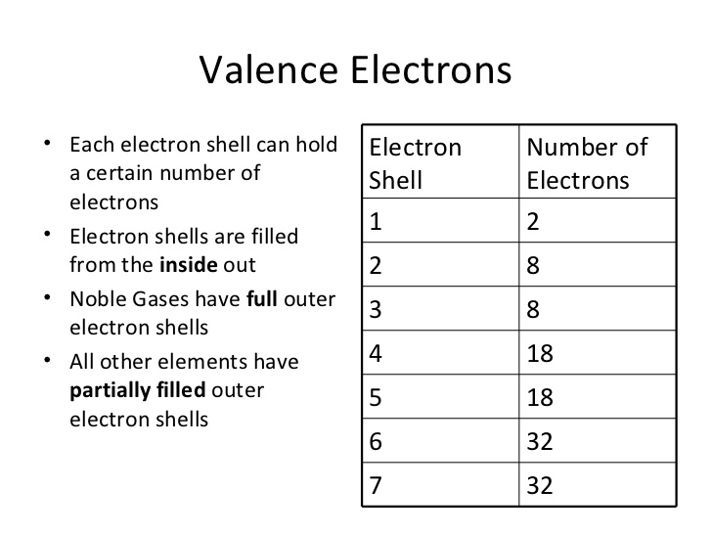 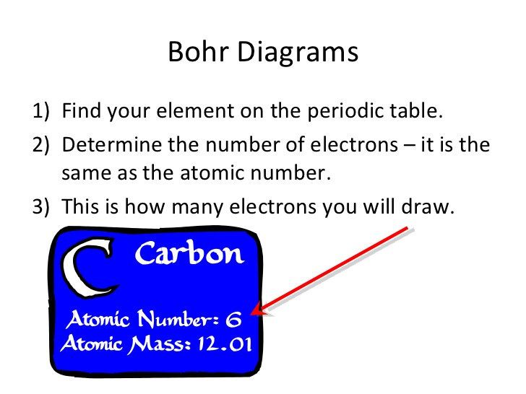

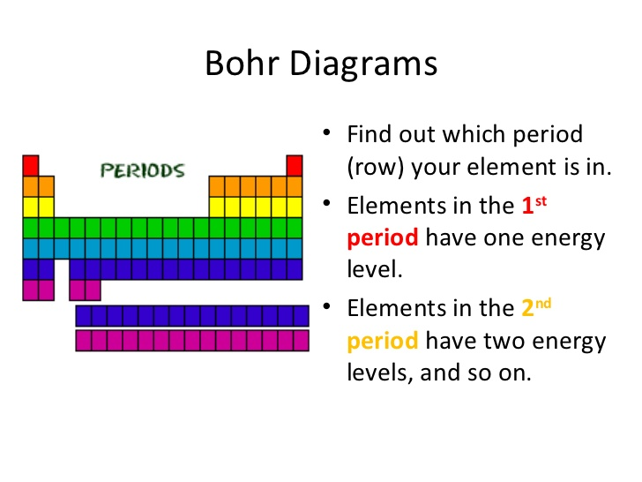 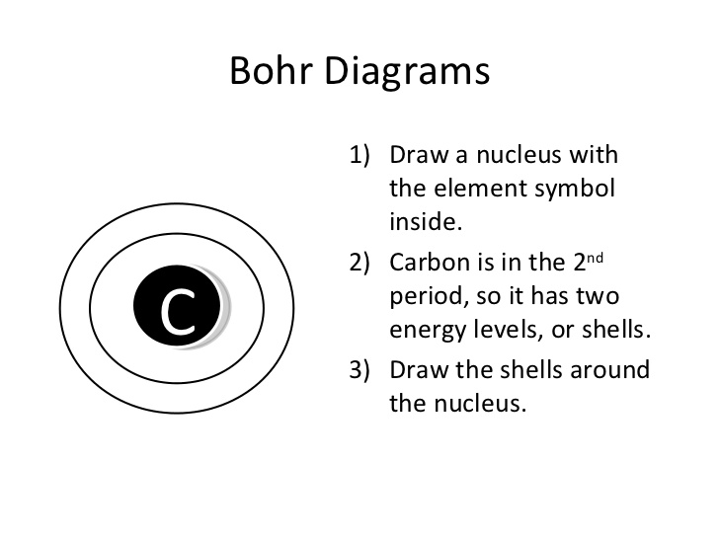

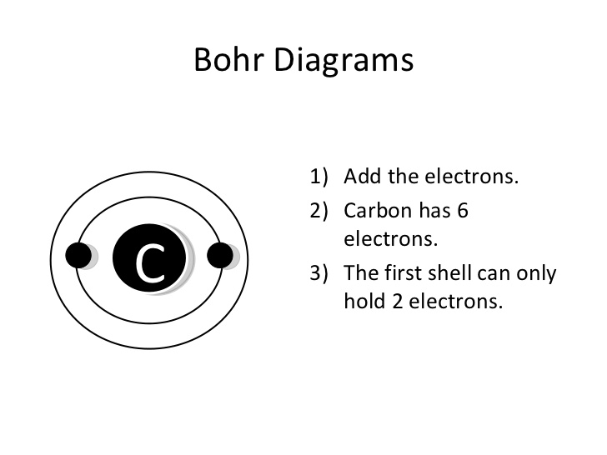 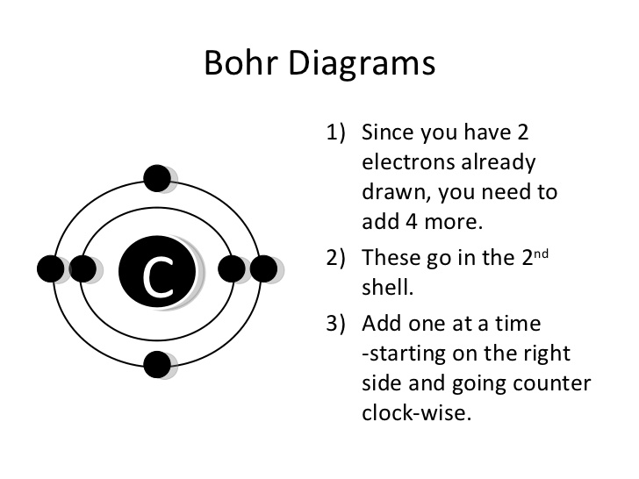

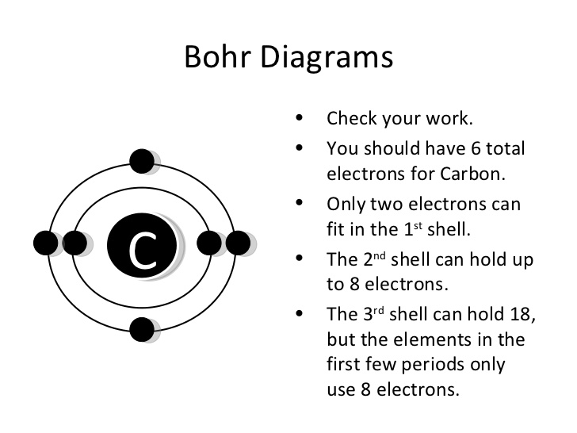 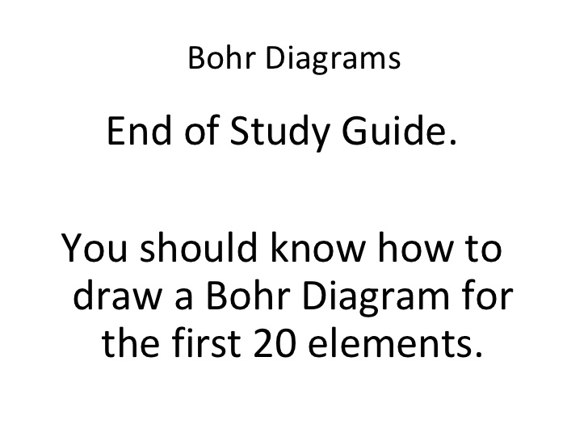

**How to draw a Lewis Dot Structure**

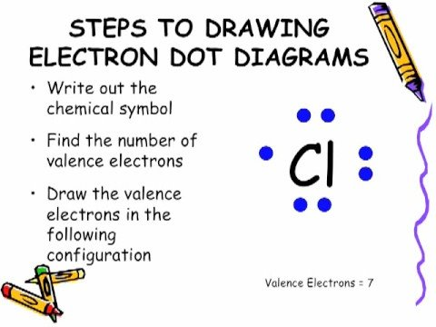

**Cl is in Group 7 so we know it has seven valence electrons while having 17 total electrons because Cl’s atomic number is 17. Chlorine will have 17 protons because the atomic number is 17.**

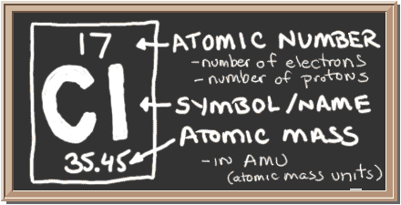

**How to find how many neutrons are in an atom of an element**

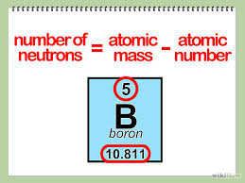

**Remember to round the atomic mass to the nearest whole number (the leftover bits have to do with isotopes of the element.**

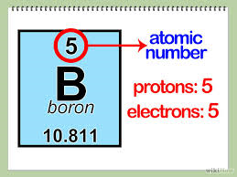

**Isotopes are variants of a particular chemical element such that, while all isotopes of a given element have the same number of protons in each atom, they differ in neutron number. So the atomic mass listed on the periodic table is an average mass from all the isotopes.**

